Administer and govern Microsoft Fabric.docx
I’ve structured this exactly for DP-600 / Fabric administration & governance exam prep, with only what appears in the document, no assumptions.

✅ Microsoft Fabric – Administration & Governance
Exam-Focused Summary (from the document)

1. Role of a Microsoft Fabric Administrator
A Fabric admin (formerly Power BI admin) is responsible for managing, securing, monitoring, and governing the Fabric environment across the organization.
Admins primarily work in:
- Fabric Admin Portal
- Microsoft 365 Admin Center
- Microsoft Purview Compliance Portal
- Microsoft Entra ID (Azure AD)
- PowerShell cmdlets
- Admin APIs & SDKs

2. Core Fabric Architecture Concepts
All Fabric data is stored in OneLake, built on Azure Data Lake Storage (ADLS) Gen2.
There is one OneLake per tenant, providing a single unified data storage layer.

Key Objects:
- Tenant
  - Root of OneLake
  - Aligned with Microsoft Entra ID
- Capacity
  - Dedicated compute resources
  - Provided via Fabric SKU or Trials
- Domain
  - Logical grouping of workspaces (e.g., Sales, Finance)
- Workspace
  - Container for Fabric items
  - Uses capacity
  - Controls user access
- Items
  - Lakehouses, warehouses, pipelines, datasets, reports, dashboards

3. Admin Responsibilities

Security & Access Control
Admins manage security using role-based access control (RBAC):
- Workspace roles
- Item permissions
- Granular permissions
- OneLake RBAC (preview)

Data Governance
Admins:
- Secure inbound and outbound connectivity
- Monitor usage and performance
- Apply governance policies

Customization & Configuration
Examples:
- Configure private links
- Define data classification policies
- Manage tenant settings

Monitoring & Optimization
Admins:
- Monitor capacity usage
- Configure alerts
- Troubleshoot refresh and connectivity issues

4. Fabric Admin Tools

Fabric Admin Portal
Used to:
- Manage tenant and capacity settings
- Enable/disable Fabric
- Manage admins and users
- View audit logs
- Monitor performance

Admin Monitoring Workspace
Includes:
- Feature Usage and Adoption dataset
- Reports for usage and performance insights

5. Licensing & User Access
- User licenses are managed in Microsoft 365 Admin Center
- Licenses control access and functionality
- Admins control sharing and distribution of Fabric content

6. Data Governance Features in Fabric

Endorsement
Builds trust in data assets:
- Promoted
  - Can be set by contributors or admins
- Certified
  - Requires formal admin-managed review process

Metadata Scanning
- Uses Scanner API
- Scans Fabric items for sensitive data
- Supports structured and unstructured data

Data Lineage
- Tracks data flow across Fabric items
- Used for impact analysis

7. Fabric Security Evaluation Order (Very Exam-Important)
Access is evaluated sequentially:
- Microsoft Entra ID authentication
- Fabric access
- Data security

8. Fabric Security Building Blocks

Workspace Roles (apply to all items)
- Admin
- Member
- Contributor
- Viewer

Item Permissions
- Override or refine workspace roles
- Share individual items

Granular Permissions
Applied via:
- SQL Analytics Endpoint
- Semantic Models
- Warehouses

OneLake Data Access Controls (Preview)
- Folder-level RBAC
- Inherited by subfolders

9. Lakehouse Security
Lakehouse structure:
- /Tables → accessed via SQL Analytics Endpoint
- /Files → accessed via Lake view
Admins can secure:
- SQL objects (views, procedures)
- Files and folders via OneLake roles

10. Warehouse Security Features
Supported security mechanisms:
- Dynamic Data Masking (DDM)
- Row-Level Security (RLS)
- Column-Level Security (CLS)
- GRANT / DENY / REVOKE permissions

Dynamic Data Masking Types:
- Default
- Email
- Custom text (partial)
- Random

11. Row-Level Security (RLS)
Implemented using:
- Filter predicates (inline table-valued functions)
- Security policies
Best practices:
- Separate schema for predicates
- Avoid type conversions
- Minimize joins for performance

12. Semantic Model Security
- Workspace role grants base access
- DAX-based RLS for granular control
- Item permissions can refine access

13. Microsoft Purview Integration
Purview enhances Fabric governance with:
- Data Map
- Unified Catalog
- Information Protection
- DLP
- Audit

Purview Hub in Fabric
Provides:
- Overview dashboards
- Sensitivity labels
- Endorsement insights
- Domains
- Item explorer

14. Data Governance Fundamentals
Governance includes:
- Auditing
- Evaluation
- Documentation
- Management
- Protection
Benefits:
- Single source of truth
- Improved data quality
- Faster compliance
- Reduced costs

🎯 What to Memorize for the Exam
- OneLake = single tenant-wide storage
- Access evaluation order (Entra ID → Fabric → Data)
- Workspace roles vs item permissions
- RLS / CLS / DDM differences
- Purview vs built-in Fabric governance
- Admin portal responsibilities
If you want next:
- ✅ 1-page DP-600 cheat sheet
- ✅ Exam-style MCQs from this document
- ✅ Security comparison table (Workspace vs Item vs OneLake)

Administer a Microsoft Fabric environment
- Describe Fabric admin tasks
- Navigate the admin center
- Manage user access
- Govern data in Fabric

As a Fabric administrator (admin), you need to know:
- Fabric architecture
- Security and governance features
- Analytics capabilities
- Deployment and licensing options
All data in Fabric is stored in OneLake, which is built on Azure Data Lake Storage (ADLS) gen2 architecture. OneLake is hierarchical in nature to simplify management across your organization. There's only one OneLake per tenant and it provides a single-pane-of-glass file-system namespace that spans across users, regions, and even clouds.

Understand Fabric concepts
Tenant is a dedicated space for organizations to create, store, and manage Fabric items. There's often a single instance of Fabric for an organization, which is aligned with Microsoft Entra ID. The Fabric tenant maps to the root of OneLake and is at the top level of the hierarchy.
Capacity is a dedicated set of resources that is available at a given time to be used. A tenant can have one or more capacities associated with it. Capacity defines the ability of a resource to perform an activity or to produce output. Capacity needs vary by item and duration of use. Fabric offers capacity through the Fabric SKU and Trials.
Domain is a logical grouping of workspaces. Domains are used to organize items in a way that makes sense for your organization. You can group things together in a way that makes it easier for the groups of people to have access to workspaces. For example, you might have a domain for sales, another for marketing, and another for finance.

Workspace is a collection of items that brings together different functionality in a single tenant. It acts as a container that uses capacity for the work that is executed, and provides controls for who can access the items in it. For example, in a sales workspace, users associated with the sales organization can create a data warehouse, run notebooks, create datasets, create reports, and more.
Items are the building blocks of the Fabric platform. They're the objects that you create and manage in Fabric. There are different types of items, such as data warehouses, data pipelines, datasets, reports, and dashboards.

If you're a Microsoft 365 admin, a Power Platform admin, or a Fabric capacity admin, you're involved in administering Fabric. The Fabric admin role was formerly known as Power BI admin.
As a Fabric admin, you work primarily in the Fabric admin portal. You might also need to familiarize yourself with the following tools:
- Microsoft 365 admin center
- Microsoft 365 Security & Microsoft Purview compliance portal
- Microsoft Entra ID in the Azure portal
- PowerShell cmdlets
- Administrative APIs and SDK

Describe admin tasks
As an admin, you might be responsible for a wide range of tasks to keep the Fabric platform running smoothly. These tasks include:
Security and access control: One of the most important aspects of Fabric administration is managing security and access control to ensure that only authorized users can access sensitive data. You can use role-based access control (RBAC) to:
- Define who can view and edit content.
- Set up data gateways to securely connect to on-premises data sources.
- Manage user access with Microsoft Entra ID.
Data governance: Effective Fabric administration requires a solid understanding of data governance principles. You should know how to secure inbound and outbound connectivity in your tenant and how to monitor usage and performance metrics. You should also know how to apply data governance policies to ensure data within your tenant is only accessible to authorized users.
Customization and configuration: Fabric administration also involves customizing and configuring the platform to meet the needs of your organization. You might configure private links to secure your tenant, define data classification policies, or adjust the look and feel of reports and dashboards.
Monitoring and optimization: As a Fabric admin, you need to know how to monitor the performance and usage of the platform, optimize resources, and troubleshoot issues. Examples include configuring monitoring and alerting settings, optimizing query performance, managing capacity and scaling, and troubleshooting data refresh and connectivity issues.
Fabric admins can perform most admin tasks using one or more of the following tools: the Fabric admin portal, PowerShell cmdlets, admin APIs and SDKs, and the admin monitoring workspace.
Fabric admin portal
Fabric's admin portal is a web-based portal where you can manage all aspects of the platform. You can centrally manage, review, and apply settings for the entire tenant or by capacity in the admin portal. You can also manage users, admins and groups, access audit logs, and monitor usage and performance.
The admin portal enables you to turn settings on and off. There are many settings located in the admin portal. One noteworthy setting is the Fabric on/off switch, located in tenant settings that lets organizations that use Power BI opt into Fabric.

PowerShell cmdlets
Fabric provides a set of PowerShell cmdlets that you can use to automate common administrative tasks. A PowerShell cmdlet is a simple command that can be executed in PowerShell.
For example, you can use APIs and SDKs to create and manage groups, configure data sources and gateways, and monitor usage and performance. You can also use the APIs and SDKs to manage the Fabric admin APIs and SDKs.
You can make these requests using any HTTP client library that supports OAuth 2.0 authentication, such as Postman, or you can use PowerShell scripts to automate the process.

Admin monitoring workspace
Fabric tenant admins have access to the admin monitoring workspace. You can choose to share access to the workspace or specific items within it with other users in your organization. The admin monitoring workspace includes the Feature Usage and Adoption dataset and report, which together provide insights on the usage and performance of your Fabric environment. You can use this information to identify trends and patterns, and troubleshoot issues.
User licenses control the level of user access and functionality within the Fabric environment. Administrators ensure licensed users have the access they need to data and analytics to do their jobs effectively. They also limit access to sensitive data and ensure compliance with data protection laws and regulations.
License management for Fabric is handled in the Microsoft 365 admin center.
As an admin, you can manage how users share and distribute content. You can manage how users share content with others, and how they distribute content to others. You can also manage how users interact with items, such as data warehouses, data pipelines, datasets, reports, and dashboards.
Govern data in Fabric
Fabric includes built-in governance features to help you manage and control your data. Endorsement is a way for you as an admin to designate specific Fabric items as trusted and approved for use across the organization.
Admins can also make use of the scanner API to scan Fabric items for sensitive data, and the data lineage feature to track the flow of data through Fabric.
Endorsement is a key governance feature that builds trust in your data assets by marking Fabric items as reviewed and approved. Endorsed items display a badge, signaling to users that these assets are reliable. Endorsement helps users trust the data, and it also helps you as an admin manage the overall growth of items across your environment.
Promoted Fabric content appears with a Promoted badge in the Fabric portal. Workspace members with the contributor or admin role can promote content within a workspace. The Fabric admin can promote content across the organization.
Certified content requires a more formal process that involves a review of the content by a designated reviewer. Content appears with a Certified badge in the Fabric portal. Admins manage the certification process and can customize it to meet the needs of your organization.

Scan for sensitive data
Metadata scanning facilitates governance of data by enabling cataloging and reporting on all the metadata of your organization's Fabric items. The scanner API is a set of Admin REST APIs that allows you to scan Fabric items for sensitive data. Use the scanner API to scan data warehouses, data pipelines, datasets, reports, and dashboards for sensitive data. The scanner API can be used to scan both structured and unstructured data.
A security use case in Fabric refers to a set of users needing data access and accessing data in a specific way. Once a use case is identified, Fabric permissions associated with that use case can be configured.
- Data engineers need access to data in a lakehouse to develop downstream data products.
- Business or data analysts need to query data to answer business questions.
- Data scientists need to access data in a lakehouse and consume it through Apache Spark to create models and experiments.
- Report creators need to build reports to share with report consumers.
- Report consumers need to view data in Power BI reports to make decisions.
Fabric has three security levels and they're evaluated sequentially to determine whether a user has data access. The order of evaluation for access is:
- Microsoft Entra ID authentication: checks if the user can authenticate to the Azure identity and access management service, Microsoft Entra ID.
- Fabric access: checks if the user can access Fabric.
- Data security: checks if the user can perform the action they've requested on a table or file.
The third level, data security, has several building blocks that can be configured individually or together to align with different access requirements. The primary access controls in Fabric are:
- Workspace roles
- Item permissions
- Compute or granular permissions
- OneLake data access controls (preview)
It's helpful to envision these building blocks in a hierarchy to understand how access controls can be applied individually or together.
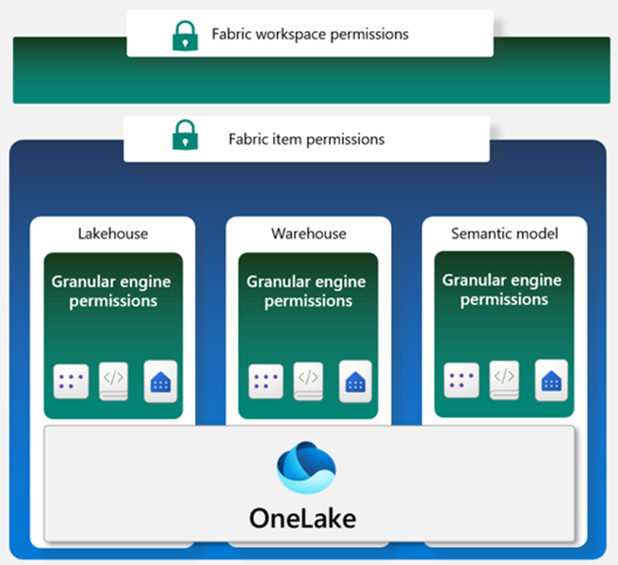
A workspace in Fabric enables you to distribute ownership and access policies using workspace roles. Within a workspace, you can create Fabric data items like lakehouses, data warehouses, and semantic models. Item permissions can be inherited from a workspace role or set individually by sharing an item. When workspace roles provide too much access, items can be shared using item permissions to ensure proper security.
Within each data item, granular engine permissions such as Read, ReadData, or ReadAll can be applied.
Compute or granular permissions can be applied within a specific compute engine in Fabric, like the SQL Endpoint or semantic model.
Fabric data items store their data in OneLake. Access to data in the lakehouse can be restricted to specific files or folders using the role-based-access control (RBAC) feature called OneLake data access controls (preview).
Workspaces are environments where users can collaborate to create groups of items. Items are the resources you can work with in Fabric such as lakehouses, warehouses, and reports. Workspace roles are preconfigured sets of permissions that let you manage what users can do and access in a Fabric workspace.
Item permissions control access to individual Fabric items within a workspace. Item permissions let you either adjust the permissions set by a workspace role or give a user access to one or more items within a workspace without adding the user to a workspace role.
Workspace roles control what users can do and access within a Fabric workspace. There are four workspace roles and they apply to all items within a workspace. Workspace roles can be assigned to individuals, security groups, Microsoft 365 groups, and distribution lists. Users can be assigned to the following roles:
- Admin - Can view, modify, share, and manage all content and data in the workspace, and manage permissions.
- Member - Can view, modify, and share all content and data in the workspace.
- Contributor - Can view and modify all content and data in the workspace.
- Viewer - Can view all content and data in the workspace, but can't modify it.

In the Grant people access window that appears after selecting Manage permissions, if you add the user and don't select any of the checkboxes under Additional permissions, the user will have read access to the lakehouse metadata. The user won't have access to the underlying data in the lakehouse. To grant the engineer the ability to read data and not just metadata, Read all SQL endpoint data or Read all Apache Spark can be selected.
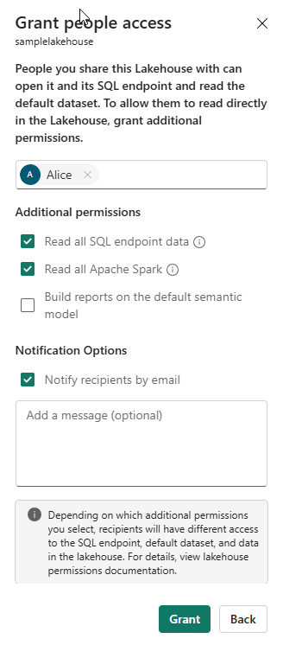

Apply granular permissions
Completed100 XP
- 6 minutes
When the permissions provided by workspace roles or item permissions are insufficient, granular permissions like table and row-level security and file and folder access can be set through the:
- SQL analytics endpoint
- OneLake data access roles (preview)
- Warehouse
- Semantic model

Configure data access through the SQL analytics endpoint in a lakehouse
Data in a lakehouse can be read through the SQL analytics endpoint. Each Lakehouse has an autogenerated SQL analytics endpoint that can be used to transition between the lake view of the lakehouse and the SQL view of the lakehouse. The lake view supports data engineering and Apache Spark and the SQL view of the same lakehouse allows you to create views, functions, stored procedures and to apply SQL security and object level permissions.
Data in a Fabric lakehouse is stored with the following folder structure:
- /Files
- /Tables

View the SQL analytics endpoint view of the lakehouse
The SQL analytics endpoint is used to read data in the /Tables folder of the lakehouse using T-SQL.

Secure a Microsoft Fabric data warehouse
- Learn the concepts of securing a data warehouse in Microsoft Fabric.
- Learn how to implement dynamic data masking to obscure sensitive information.
- Learn how to configure row-level security to provide granular control.
- Learn how to implement column-level security to protect sensitive data.
- Learn how to configure granular permissions using T-SQL.
Dynamic Data Masking (DDM) is a security feature that limits data exposure to nonprivileged users by obscuring sensitive information. real-time masking feature.
Masking Type | Description | Use Case | Limitations | Masking Rule
Default | Full masking according to the data types of the designated fields. | Useful when you want to completely hide the actual data. | Completely mask the data. No information is visible. | default()
Email | Exposes the first letter of an email address and the constant suffix ".com" | Useful when you want to show that the data field contains an email without revealing the actual email. | Only applicable to email fields. | email()
Custom Text | Exposes the first and last 'n' characters and adds a custom padding string in the middle. | Useful when you want to partially hide the actual data. | Not suitable for numeric, date, and time data types. | partial(prefix_padding, padding_string, suffix_padding)
Random | Replaces any numeric or binary value with a random number within a specified range. | Useful when you want to hide the actual numeric or binary data. | Only applicable to numeric and binary data types. | random(low, high)
The prefix_padding and suffix_padding parameters in the partial() function specify the number of characters to expose at the beginning and end of the string, and the padding_string parameter specifies the string to use for masking the remaining characters.
The low and high parameters in the random() function specify the range of random numbers to generate.
Row-Level Security (RLS) works by associating a function, known as a security predicate, with a table. This function is defined to return true or false based on certain conditions, typically involving the values of one or more columns in the table.
Row-level security is implemented in two main steps:
- Filter predicates - It's an inline table-valued function that filters the results based on the predicate defined.
- Security policy - It's a security policy that invokes an inline table-valued function to protect access to the rows in a table.

Explore use cases
Row-level security is ideal for many scenarios, including:
- When you need to isolate departmental access at the row level.
- When you need to restrict customers' data access to only the data relevant to their company.
- When you need to restrict access for compliance purposes.

Apply best practices
Here are a few best practices to consider when implementing RLS:
- It's recommended to create a separate schema for predicate functions, and security policies.
- Whenever possible, avoid type conversions in predicate functions.
- To maximize performance, avoid using excessive table joins and recursion in predicate functions.
Column-level security (CLS) allows you to restrict column access in order to protect sensitive data
Aspect | Column-Level Security | Views
Granularity of Access Control | Allows control at a more granular level. Can specify different access rights for different users or roles on different columns within the same table. | Would need to create different views for different sets of permissions.
Maintenance | Permissions are tied to the columns themselves, so they automatically adapt to changes in table structure. | If the underlying table structure changes, views may need to be updated to reflect these changes.
Performance | Generally more efficient because it operates directly on the table data. | Can introduce performance overhead, especially if they are complex or if the underlying tables are large.
Transparency | The restrictions are transparent to the user. The user queries the table as usual, and the database engine takes care of applying the security rules. | The user needs to query a different object (the view instead of the table).
Flexibility | Less flexible than views. | Very flexible and can provide row-level security (by including a WHERE clause in the view definition) in addition to column-level security. They can also transform the data (for example, by calculating derived columns) which is not possible with column-level security.

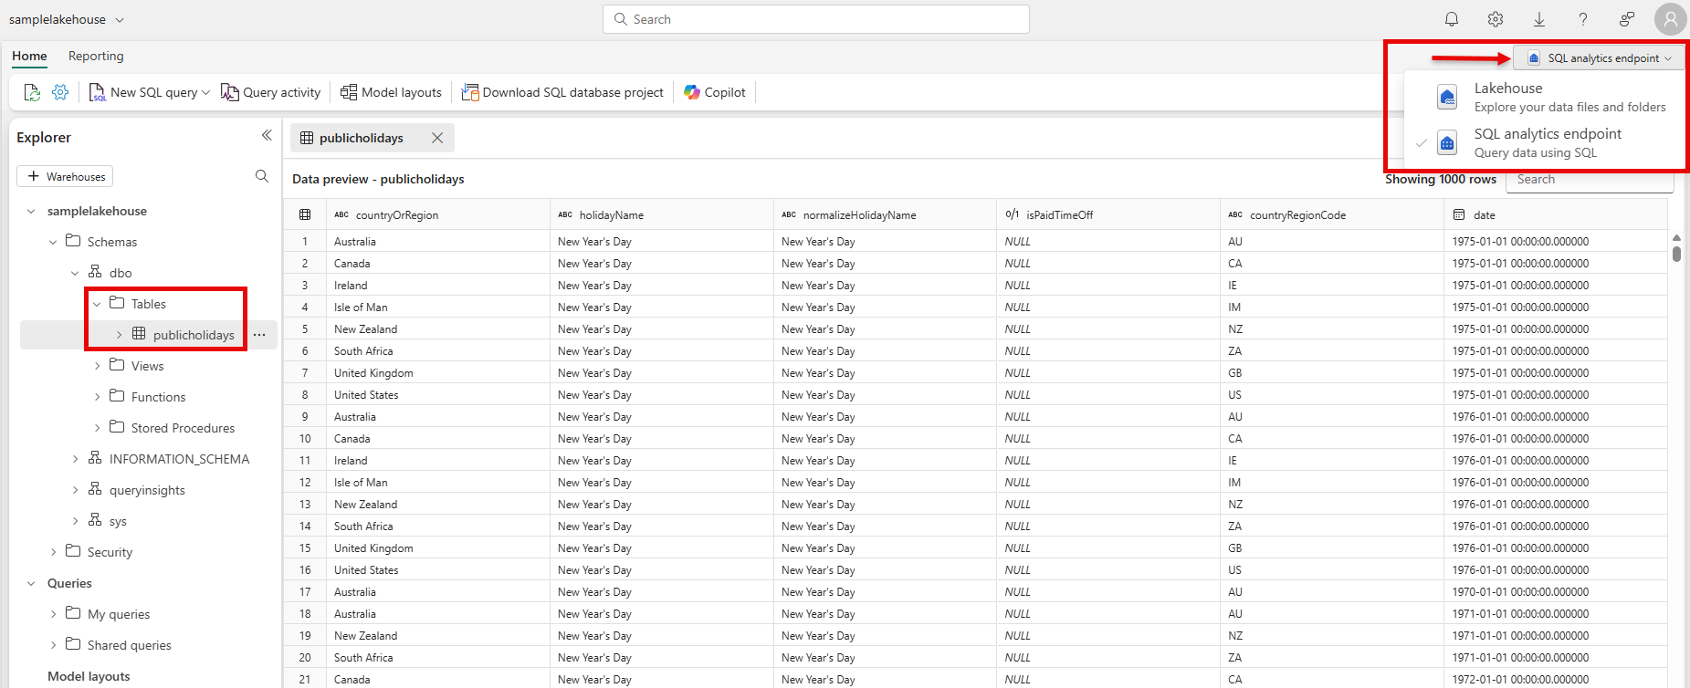

Apply granular permissions to the lakehouse using T-SQL
Using the SQL analytics endpoint, granular T-SQL permissions can be applied to SQL objects using Data Control Language (DCL) commands such as:
- GRANT
- DENY
- REVOKE
Row-level security, column-level security, and dynamic data masking can also be applied using the SQL analytics endpoint. See:
- Row-level security
- Column-level security
- Dynamic data masking

Configure data access through the lake view of the lakehouse
The lake view of the lakehouse is used to read data in the /Tables and /Files folder of the lakehouse.
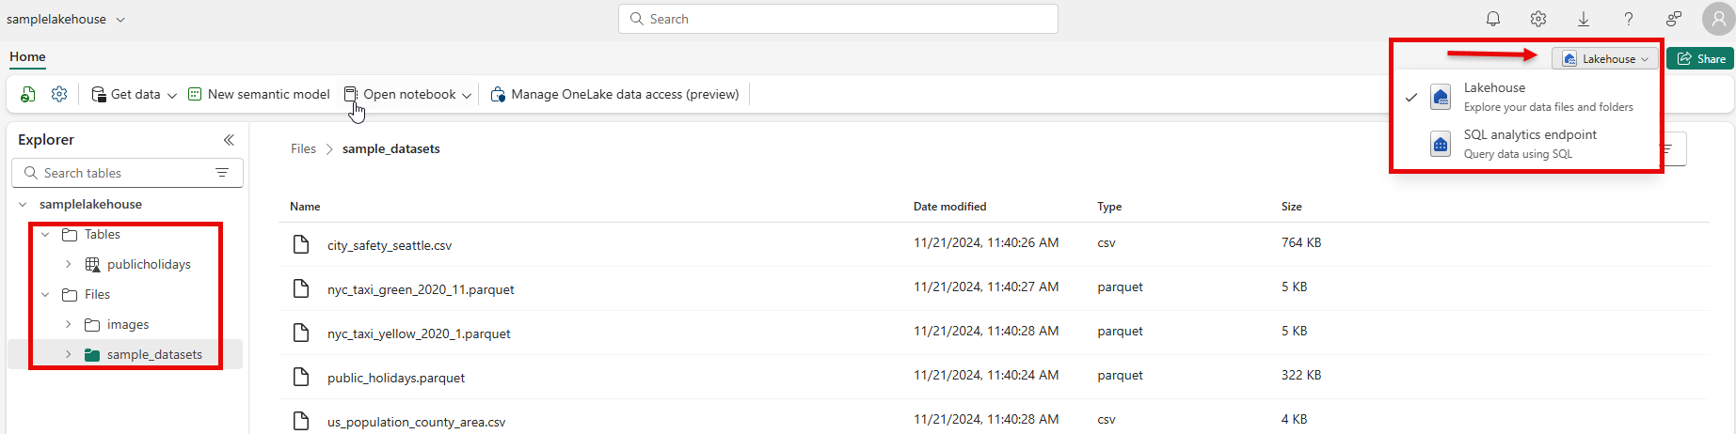

Use OneLake data access roles to secure data
Workspace and item permissions provide coarse access to data in a lakehouse. To further refine data access, folders in the lake view of the lakehouse can be secured using OneLake data access roles (preview). You can create custom roles within a lakehouse and grant read permissions only to specific folders in OneLake. Folder security is inheritable to all subfolders. To create a custom OneLake data access role:
- Select Manage OneLake data access (preview) from the menu in the lake view of the lakehouse. 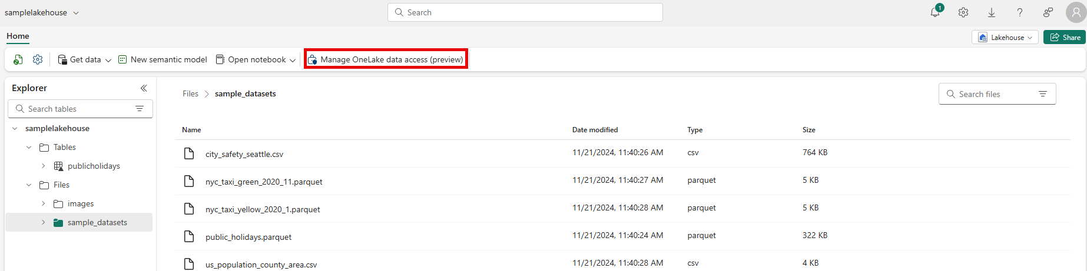
- In the New Role window, create a new role name and select the folders to grant access to.
- Once the role is created, assign a user or group to the role and select the permissions to assign.
Tip
For more information on how OneLake RBAC permissions are evaluated with workspace and item permissions, see: How OneLake RBAC permissions are evaluated with Fabric permissions

Configure granular warehouse permissions
Granular permissions can be applied to warehouses using the SQL analytics endpoint, similar to the way the endpoint is used for the lakehouse. The same permissions can be applied: GRANT, REVOKE, and DENY and row-level security, column-level security, and dynamic data masking.
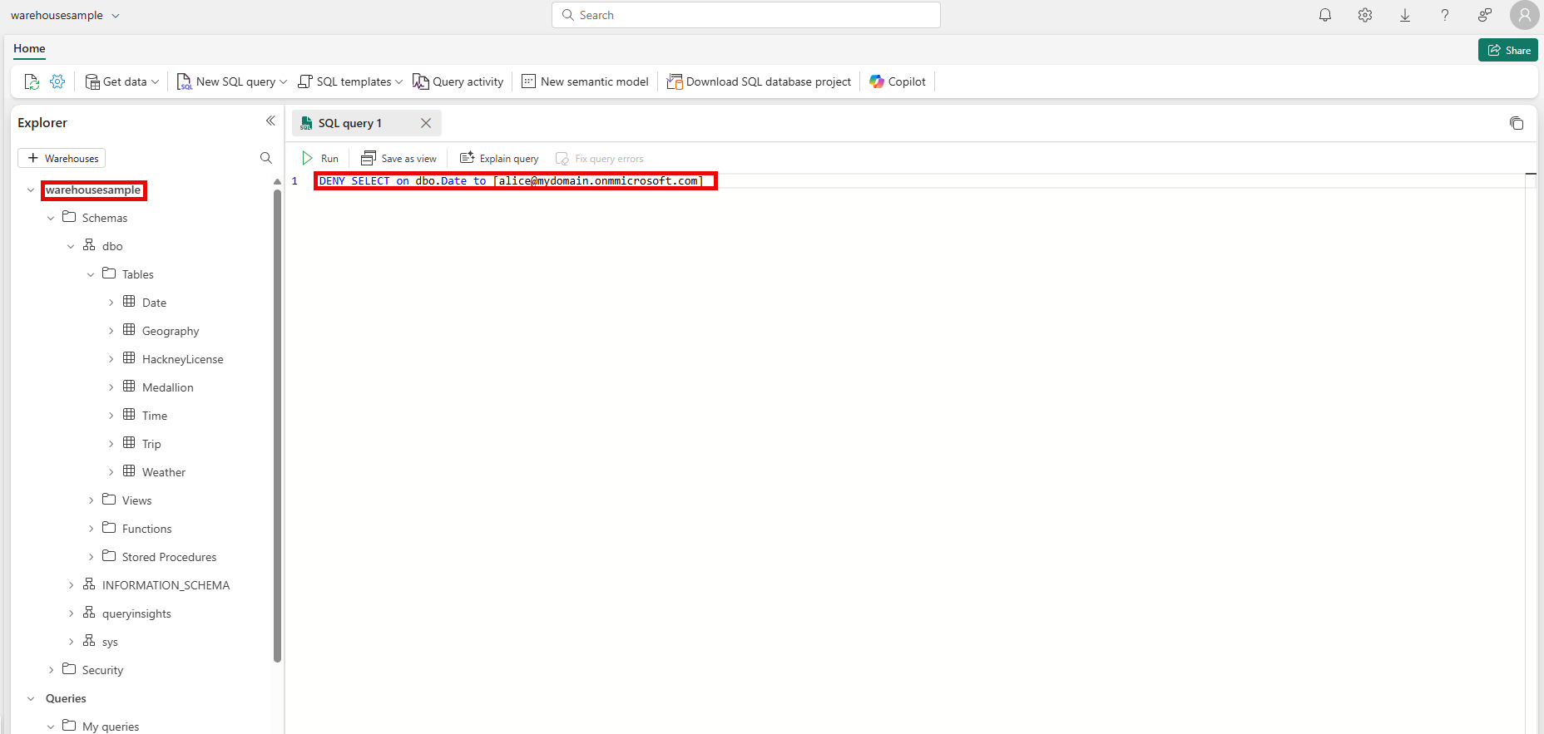

Configure Semantic model permissions
A user's role in a workspace implicitly grants them permission on the semantic models in a workspace. Semantic models allow for security to be defined using DAX. More granular permission can be applied using row-level security (RLS). To learn more about the managing RLS or permissions on the semantic model see:
- Workspaces roles – Designed to provide different levels of access and control within the workspace. You can assign users to the various workspace roles such as Admin, Member, Contributor, and Viewer. These roles are crucial for maintaining the security and efficiency of data warehousing operations within an organization.
- Item permissions – Individual warehouses can have item permissions assigned directly to them. The main intent behind assigning such permissions is to facilitate the sharing of the Warehouse for downstream use.
- Data protection security – For more precise control, you can use T-SQL to grant specific permissions to users. Warehouse supports a range of data protection features that enable administrators to shield sensitive data from unauthorized access. This includes object-level security for database objects, column-level security for table columns, row-level security for table rows using WHERE clause filters, and dynamic data masking to obscure sensitive data like email addresses. These features ensure data protection across Warehouses and SQL analytics endpoints without necessitating changes to applications.
always be cautious when using dynamic SQL due to the risk of SQL injection attacks. Always use parameterization methods like sp_executesql or QUOTENAME to sanitize inputs.

Govern data in Microsoft Fabric with Purview

Microsoft Purview has a data governance solution designed to help you discover, catalog, and manage data assets across your organization. It provides a unified view of your data estate by scanning and cataloging metadata from various data sources, including Microsoft Fabric. Purview has three pillars: data governance, data security, and risk and compliance. In this module, we'll focus on data governance.
Fabric is Microsoft's end-to-end analytics and data platform. The platform can store, move, process, ingest, transform, and analyze your data regardless of its size and current format. Once you have data in the location and format you need it, advanced business intelligence features can be used to analyze data, and generate insights to support your decision making.

OneLake
In Fabric, all information is stored in a data lake, which can hold both structured and unstructured data. Microsoft's implementation of the data lake is called OneLake and is built on Azure Data Lake Storage (ADLS) generation 2. With all data residing in OneLake, there's a single copy of data that doesn't need to be moved or duplicated. This single underlying storage mechanism helps ensure that policies and security controls are applied universally.
Data governance is the practice of managing data to ensure the quality, consistency, security, and usability of data. It involves setting up a framework that includes roles, responsibilities, processes, policies, and standards that are used to manage data throughout its lifecycle.
A data governance program usually includes:
- Auditing: Recording where data originates and who modifies it.
- Evaluation: Assessing the usefulness and accuracy of data.
- Documentation: Providing clear descriptions of data to support informed use.
- Management: Correcting inaccurate data, fulfilling access requests, and maintaining compliance with data legislation.
- Protection: Securing data from unauthorized access, ransomware threats, and other malicious attacks.
Well-governed data is reliable and readily accessible to those who need it.
In large organizations, data is often stored and managed separately across different business units, creating what are known as data silos. These silos can hinder effective data governance due to inconsistent standards and policies across teams. Breaking down these silos by integrating data—while preserving security and compliance—is essential for establishing a unified and governed data environment.
Implementing data governance can lead to benefits such as:
- A single source of truth that reduces confusion and supports decision making.
- Improved data quality.
- Faster compliance with access requests.
- Reduced data storage and management costs.

Data governance features in Microsoft Fabric
Many data governance tasks can be performed using your Microsoft Fabric license, without the need for an additional Microsoft Purview license. Let’s explore some of the built-in data governance capabilities available directly within Fabric.

Managing the data estate
Your organization’s data estate encompasses all its data assets. Managing a large data estate can be complex and resource-intensive. Microsoft Fabric simplifies managing your data estate with these tools:
- The Fabric Admin portal: control tenant settings, capacities, domains, and other objects, typically reserved for administrators.
- Tenants, domains, and workspaces: logical containers that you can use to control access to data and capabilities. Fabric administrators, for example, should have access to all settings in the tenant whereas team level data controllers might only have control of settings on their domain or workspace.
  - Domains group data that is relevant to a single business area or subject field.
  - Workspaces group Fabric items used by a single team or department.
- Capacities: These objects limit compute resource usage for all Fabric workloads.
- Metadata scanning: Scanning extracts values such as names, identities, sensitivities, endorsements, and so on, from data lakes. You can use this metadata to analyze and set governance policies.

Securing and protecting data
Secure data is safeguarded from unauthorized access and malicious attacks. It's also compliant with data storage regulations applicable in your region. Fabric includes the following tools to secure and protect data:
- Data tags: Use tags to identity the sensitivity of data and apply data retentions and protection policies.
- Workspace roles: Use roles to define the users who are authorized to access the data in a workspace.
- Data-level controls: Use controls at the level of Fabric items such as tables, rows, and columns to impose granular restrictions.
- Certifications: Fabric is compliant with many data management certifications, including HIPAA BAA, ISO/IEC 27017, ISO/IEC 27018, ISO/IEC 27001, and ISO/IEC 27701.

Encouraging data discovery and use
Data only becomes valuable when users can find and analyze it. These Microsoft Fabric features help promote data discovery and encourage meaningful use:
- OneLake data hub: This tool makes it easy for users to find and explore the data in your estate.
- Endorsement: Users endorse a Fabric item to identity it as of high quality. Endorsements help other users to trust the data that the item contains.
- Data lineage: This feature helps users to understand the flow of data between items in a workspace and the impact that a change would have.

Monitoring data usage
Fabric helps users track how data is being used through built-in monitoring tools:
- Monitoring Hub: Provides a centralized view of Microsoft Fabric activities. Users can only see activity related to Fabric items they have permission to access.
- Capacity Metrics App: Offers insights into Fabric usage and resource consumption, helping teams manage capacity effectively.

Why use Microsoft Purview with Microsoft Fabric?
Completed100 XP
- 7 minutes
When you need data governance features beyond those built into Microsoft Fabric, Microsoft Purview provides comprehensive data governance capabilities.
In the last unit, we reviewed the built-in governance features of Microsoft Fabric. Let's assume you work for a health care provider and new regulations mean you need stricter governance for data stored in Microsoft Fabric. Now, you want to investigate what features Microsoft Purview includes that can help you comply with new regulations.
In this unit, you'll learn what capabilities Microsoft Purview adds to the built-in data governance and compliance capabilities available in Microsoft Fabric.

What is Microsoft Purview?
Microsoft Purview is a set of solutions that you can use to govern, protect, and manage data wherever it resides. It has three pillars: data governance, data security, and risk and compliance. Purview includes data governance tools for data discovery, classification, and cataloging and can be used to gain a clear understanding of your data landscape. Purview automates the identification of sensitive information and provides a centralized repository for metadata. Use it to find, manage, and govern data across various environments, both on-premises and in the cloud.
Purview also supports data security and risk and compliance management with features that monitor regulatory adherence and assess data vulnerabilities. It integrates with other Microsoft services and third-party tools. By streamlining data access controls, enforcing policies, and delivering insights into data lineage, Purview can help you maintain data integrity, comply with regulations, and use data effectively for strategic decision-making.
The Purview solutions can be accessed via the Microsoft Purview Portal.
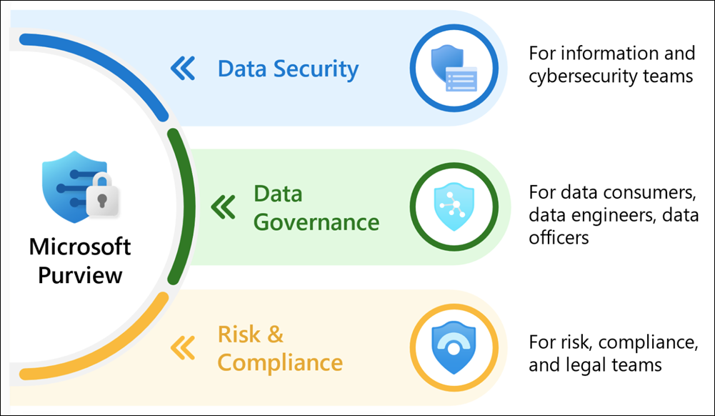

What are some of the Purview tools?
Microsoft Purview enables you to discover, manage, and protect Fabric data using Purview tools. Purview can be configured to scan your Fabric item and present data governance findings in the Purview Hub located in Fabric or in Purview itself. To unlock the following capabilities, register your Fabric tenant in Microsoft Purview.

Microsoft Purview Data Map
Data Map can be used to scan all of your data assets, to capture metadata about them and to identify sensitive data. It captures metadata about data in existing analytics, software-as-a-service, and operational systems in hybrid, on-premises, and multicloud environments. There's a built-in scanning and classification system that keeps the Data Map updated.

Microsoft Purview Unified Catalog
The Purview Unified Catalog is a searchable catalog of your scanned data where you curate, grant access to and, improve the health of your data.
In the Purview Unified Catalog, you can inventory of all your data assets, their metadata, and their lineage so you can understand the topography of your data estate. You can search for and browse datasets, and view metadata, data lineage, classification, and sensitivity labels. The Unified Catalog promotes collaboration because users can annotate datasets with tags to improve discoverability.
Suppose you work at a health care provider and regulations require you to control who can access patient records. In the Unified Catalog, users and administrators can:
- Discover where patient records are held by searching for keywords.
- Label documents and items as patient records to differentiate them from other, less sensitive information.
- Use access policies to manage self-service access requests to patient records.

Microsoft Purview Information Protection
Information Protection is used to classify, label, and protect sensitive data throughout your organization. By applying customizable sensitivity labels, you can classify records. Then policies can define access controls and enforce encryption. These labels follow the data wherever it goes, whether in emails, documents, or cloud storage, and integrate with other tools like Data Loss Prevention (DLP) to prevent unauthorized sharing. This helps organizations meet compliance requirements while safeguarding data against accidental exposure or malicious threats.
If, for example, you worked as a data steward at a health care provider, you could use Information Protection to:
- Identify data items that contain patient information, even when item titles don't identify them as patient records.
- Train classifiers to spot patient records automatically.
- Protect records with policies to encrypt data and impose Information Rights Management (IRM).

Microsoft Purview Data Loss Prevention (DLP)
DLP helps protect sensitive information with policies that automatically detect, monitor, and control the sharing or movement of sensitive data. Administrators can customize rules to block, restrict, or alert when sensitive data is transferred to prevent accidental or malicious data leaks.
If you worked at a health care provider, you would need to ensure that users don't share patient records with external parties, either accidentally or maliciously. DLP can prevent such transfers on information labeled as patient records.

Microsoft Purview Audit
Auditing solutions in Purview are used to search for activities performed in Microsoft services by users and admins. User activities such as creating files or accessing Fabric items are automatically logged and appear in the Purview audit log.
Thorough auditing is an important protection for the policies you apply to patient records. For example, if a malicious administrator changes DLP policies so that they can copy a patient record to a USB device, this change is recorded and can be identified during later investigations.

Learn more
- Use Microsoft Purview to govern Microsoft Fabric
- Learn about Microsoft Purview

Govern data in the Microsoft Purview hub
Completed100 XP
- 11 minutes
To govern Microsoft Fabric items using Microsoft Purview, you first need to establish a connection between Fabric and Purview. Once connected, the Microsoft Purview hub becomes available within Fabric, offering in-depth analysis and insights into your Fabric items. The Purview Hub acts as a gateway between Fabric and Purview.
Imagine you're part of a healthcare organization that recently adopted Microsoft Purview. Now, you're ready to connect it to Fabric and explore the insights Purview provides on your Fabric data in the Microsoft Purview Hub.
In this unit, you'll explore the Purview hub.

Connect Purview to Fabric
The stages you must complete to connect Purview to Fabric are:
- In Purview, register your Fabric tenant as a data source from the Data Map icon in the left navigation pane:
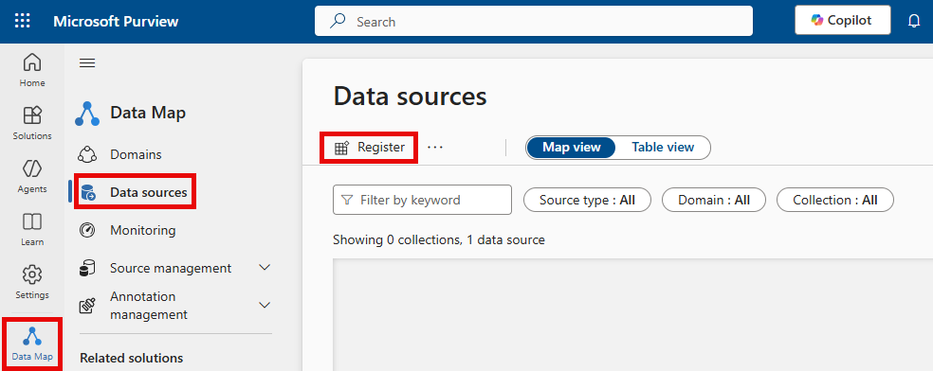
- Select Fabric as a data source.
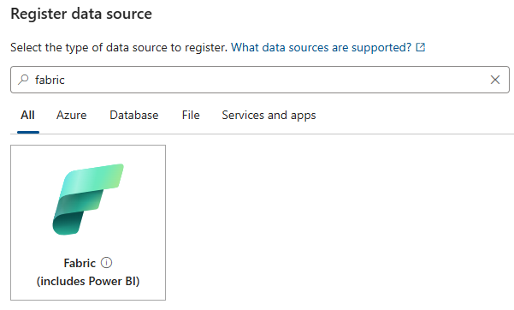
- To scan Fabric, Purview needs to authenticate with it. In Microsoft Entra ID, configure authentication, using for example, the managed identity of your Purview account.
- Create a scan in Purview that uses the Fabric data source.
Note
To configure authentication to Fabric from Purview, see
- Connect to your Microsoft Fabric tenant in the same tenant as Microsoft Purview
- Connect to your Microsoft Fabric tenant from Microsoft Purview in a different tenant

What is the Microsoft Purview hub in Microsoft Fabric?
Once Purview and Fabric are connected, the Purview hub in Fabric displays reports and insights about your Fabric items. It acts as a centralized location to begin data governance and acts as a gateway to access more advanced features in Microsoft Purview.
To see the Purview hub, in Microsoft Fabric, open the Fabric settings, and then select Microsoft Purview hub.
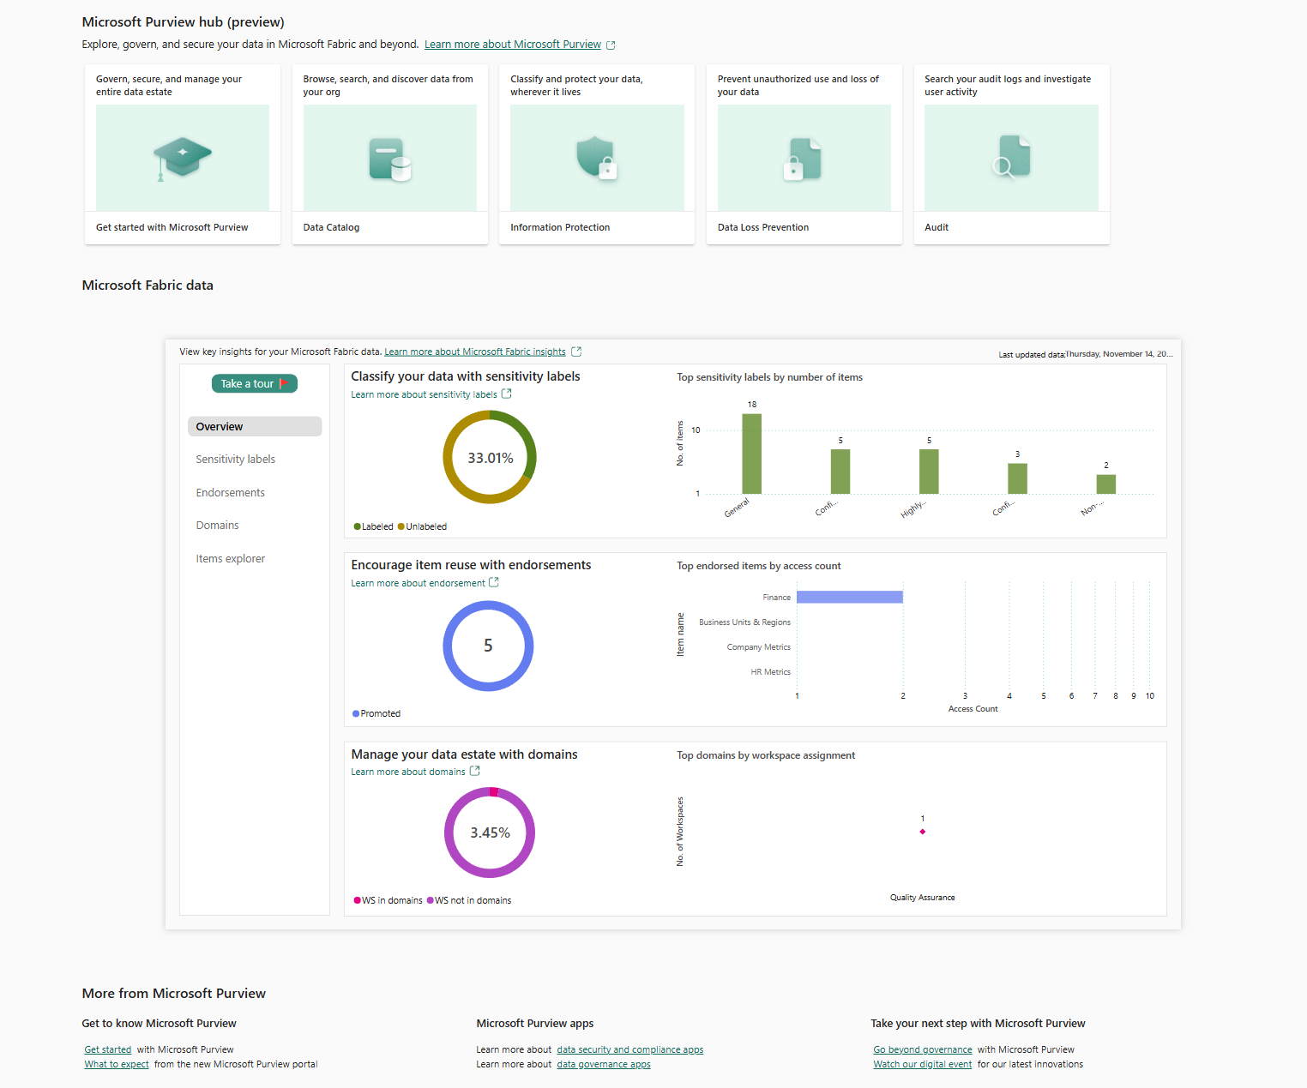
The tiles at the top of the Purview hub enable you to access advanced governance and compliance capabilities in Purview. The Purview hub report provides dashboards that reflect the security posture of your organization's data estate. Select the following tabs for descriptions of the report pages.
- Overview
- Sensitivity labels
- Endorsement
- Domains
- Items explorer
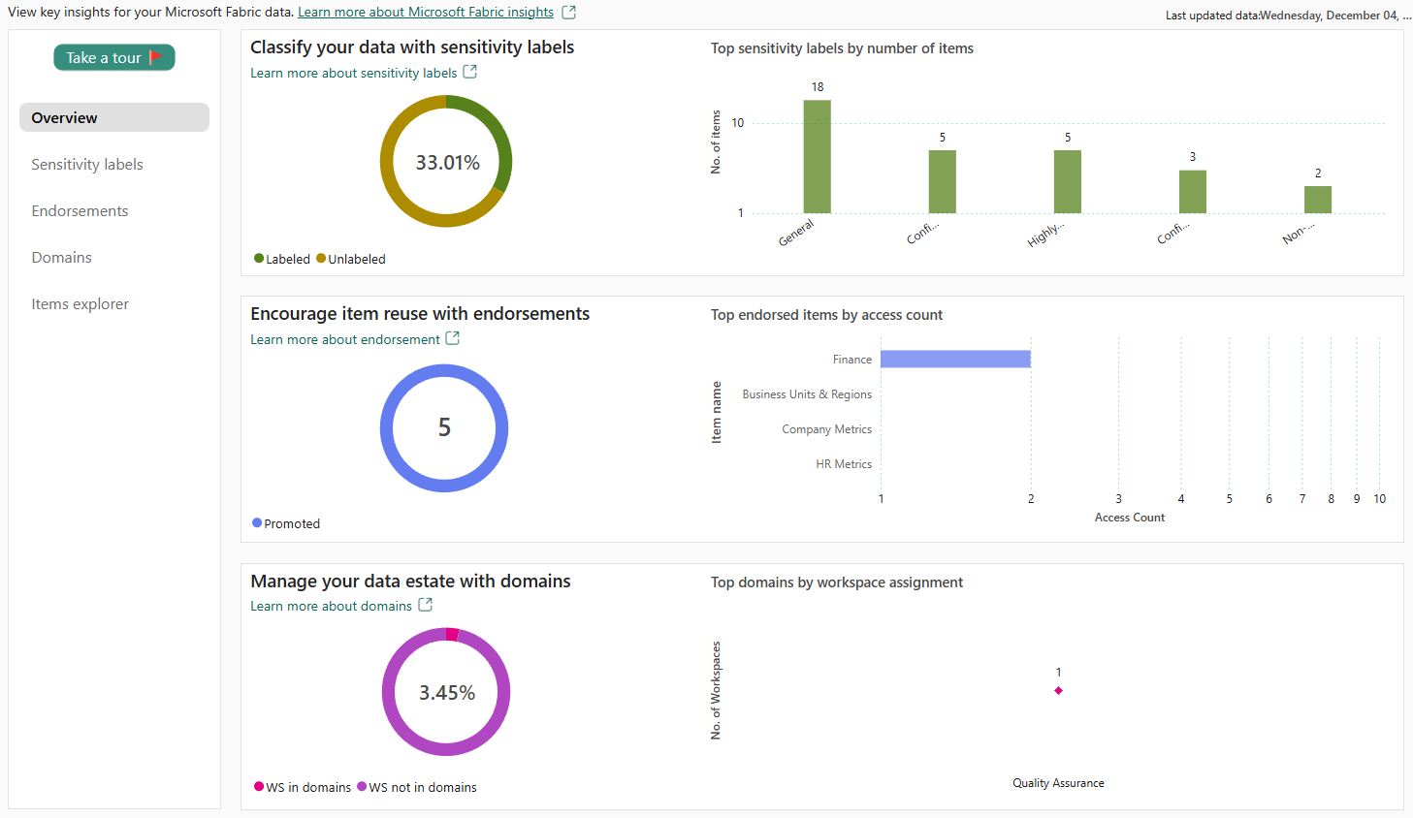
The overview page provides high-level insights about your tenant's data estate. Select the Take a tour button in the navigation pane for a quick introduction to the main features of the report.
In this module, you explored how Microsoft Purview enhances the built-in governance capabilities of Microsoft Fabric to streamline data governance. With tools like the Purview Data Map, Unified Catalog, Information Protection, Data Loss Prevention, and Purview Audit, you can gain comprehensive visibility into your organization’s data, safeguard it throughout its lifecycle, manage regulatory and risk requirements, and establish end-to-end governance.

